**Project Report**

**1. Title Page**

* **Project Title:** Movie Info Website
* **Submitted By:**
  + **Team Members:** Tirth Patel, Amiya Prakash
  + **Roll Number:** 2460494, 2460325
  + **College E-mail ID:** [tirth.manishbhai@btech.christuniversity.in](mailto:tirth.manishbhai@btech.christuniversity.in), amiya.prakash@btech.christuniversity.in
* **Course:** UI/UX Design Fundamentals
* **Instructor Name:** Ms. Nagaveena
* **Institution:** Christ University
* **Date of Submission:** 13/08/2025

**2. Abstract**

This project is a multi-page, thematic website designed to showcase and review multiple movies. The key goal was to create a visually immersive and fully responsive experience that reflects the cinematic tone of the films featured. The core technologies used were pure HTML5 and CSS3, focusing on modern layout techniques like CSS Grid and Flexbox. The final outcome is a functional and aesthetically pleasing website with a main gallery page and dedicated, uniquely styled detail pages for each movie, demonstrating a strong understanding of front-end design principles and thematic branding.

**3. Objectives**

The primary goals of this project were to:

* Design a user-friendly, cinematic interface that reflects the genre of the featured movies.
* Develop a fully responsive layout using HTML5 and CSS3 that works across desktop, tablet, and mobile devices.
* Implement a structured, multi-page site architecture with a central gallery and individual detail pages.
* Apply advanced CSS styling for thematic consistency, including custom fonts, color schemes, and image overlays.
* Utilize CSS Grid for the main movie gallery and Flexbox for aligning content within components.
* Create a reusable CSS-only star rating system for the reviews section.

**4. Scope of the Project**

This project is strictly focused on front-end design and development.

* **In-Scope:**
  + A homepage featuring a gallery of movie posters.
  + Individual detail pages for each movie, including a synopsis, cast list, and reviews.
  + Responsive design for desktop, tablet, and mobile viewports.
* **Out-of-Scope:**
  + JavaScript-based interactivity (e.g., dynamic filtering, search functionality).
  + Backend or server-side integration for managing content.
  + User accounts or comment submission functionality.

**5. Tools & Technologies Used**

|  |
| --- |
|  |

|  |  |
| --- | --- |
| **Tool/Technology** | **Purpose** |
| **HTML5** | Markup and semantic structure of the content. |
| **CSS3** | Styling, layout, responsiveness, and theming. |
| **VS Code** | Code editor for writing and managing files. |
| **Chrome DevTools** | Testing, debugging, and responsive layout validation. |
| **Google Fonts** | Importing custom fonts for a cinematic feel. |

**6. HTML Structure Overview**

The website is structured across multiple HTML files to ensure clear separation of content.

* index.html**:** The main gallery page, which contains links to all individual movie pages.
* /movies/*.html**:** A folder containing a separate HTML file for each movie (e.g., dune.html, bladerunner2049.html).
* **Semantic Tags:** The structure relies heavily on semantic HTML5 tags, including <header>, <nav>, <main>, <section>, and <footer>, to improve accessibility and code readability.

**7. CSS Styling Strategy**

A single external stylesheet (/css/style.css) is used to maintain a consistent look and feel across the entire site.

* **CSS Variables:** Variables (custom properties) were used extensively for theme management. This allowed for easy definition of a global color palette and for overriding specific colors (like the accent color) on a per-page basis to match a movie's theme.
* **Layout Techniques:**
  + **CSS Grid** was used to create the responsive movie gallery on the homepage.
  + **Flexbox** was used for aligning items within components, such as the navigation bar, cast cards, and review headers.
* **Responsive Design:** A mobile-first approach was considered, with media queries used to adapt the layout for larger screens.
* **Visual Effects:** box-shadow was used to create depth for cards, and linear-gradient overlays were applied to banner images for better text readability.

**8. Key Features**

|  |  |
| --- | --- |
| **Feature** | **Description** |
| **Movie Gallery Homepage** | A responsive grid layout on the homepage displays movie posters, linking to detail pages. |
| **Thematic Detail Pages** | Each movie page has a unique banner and accent color to match its visual identity. |
| **CSS-Only Star Rating** | A clever use of CSS gradients and custom properties to display star ratings without any images or JS. |
| **Full-Screen Banner** | The banner image on each movie page fills the viewport height (100vh) for an immersive first impression. |
| **Responsive Typography** | Relative units (rem, em) and media queries ensure text is readable on all screen sizes. |

**9. Challenges Faced & Solutions**

|  |  |
| --- | --- |
| **Challenge** | **Solution** |
| **Making each movie page feel unique without separate CSS files.** | Used CSS Variables for the accent color. This allowed the global stylesheet to be used everywhere, with a small inline <style> tag in each movie's HTML to override the --accent-color variable. |
| **Ensuring the full-screen banner image was not distorted.** | Applied background-size: cover; and background-position: center; to ensure the image always filled the space gracefully without stretching. |
| **Creating a responsive grid for the cast cards.** | Used grid-template-columns: repeat(auto-fit, minmax(180px, 1fr));, which automatically adjusts the number of columns based on the available screen width. |

**10. Outcome**

* Successfully developed a fully responsive, multi-page movie review website.
* Achieved a high-quality, visually engaging, and thematically consistent user interface.
* Demonstrated proficiency in modern CSS layout techniques, including Grid, Flexbox, and CSS Variables.
* Gained practical experience in structuring a multi-page website with shared styling.

**11. Future Enhancements**

* **Add JavaScript** to implement a dynamic search and filter functionality on the homepage.
* **Integrate a backend** (like Node.js or Firebase) to manage the movie data from a database instead of hard-coding it in HTML.
* **Implement a theme toggler** to allow users to switch between a light and dark mode.
* **Add a user comments section** on each movie page.

**12. Sample Code**

**Caption 1: HTML for the responsive movie card gallery (**index.html**)**

<section class="movie-gallery">

<!-- Movie Card for Dune -->

<a href="movies/dune.html" class="movie-card">

<img src="images/dune_poster.jpg" alt="Dune Movie Poster">

<div class="movie-card-overlay">

<h3>Dune</h3>

<p>2021</p>

</div>

</a>

<!-- Movie Card for Blade Runner 2049 -->

<a href="movies/bladerunner2049.html" class="movie-card">

<img src="images/bladerunner2049_poster.jpg" alt="Blade Runner 2049 Movie Poster">

<div class="movie-card-overlay">

<h3>Blade Runner 2049</h3>

<p>2017</p>

</div>

</a>

</section>

**Caption 2: CSS for the image-free star rating system (**style.css**)**

.star-rating {

--star-size: 20px;

--star-color: #555; /* The color of empty stars */

--star-background: var(--accent-color); /* The color of filled stars */

/* Calculate the fill percentage based on a 1-5 rating */

--percent: calc(var(--rating) / 5 * 100%);

display: inline-block;

font-size: var(--star-size);

font-family: Times; /* A font with a good star character */

line-height: 1;

}

.star-rating::before {

content: '★★★★★';

letter-spacing: 3px;

background: linear-gradient(90deg, var(--star-background) var(--percent), var(--star-color) var(--percent));

-webkit-background-clip: text;

-webkit-text-fill-color: transparent;

}

**13. Screenshots of Final Output**

Caption: Homepage Gallery

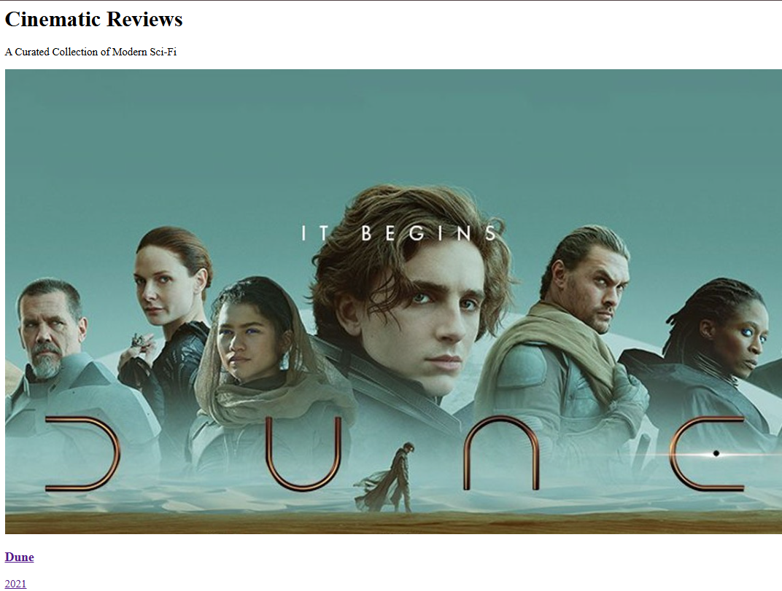

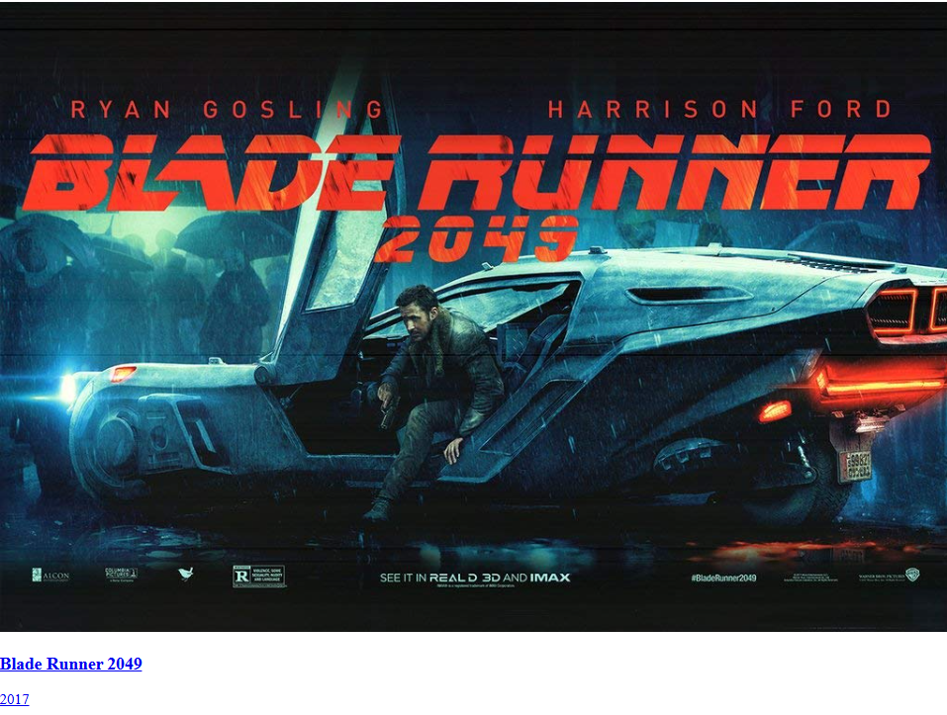

Caption: Dune Movie Page



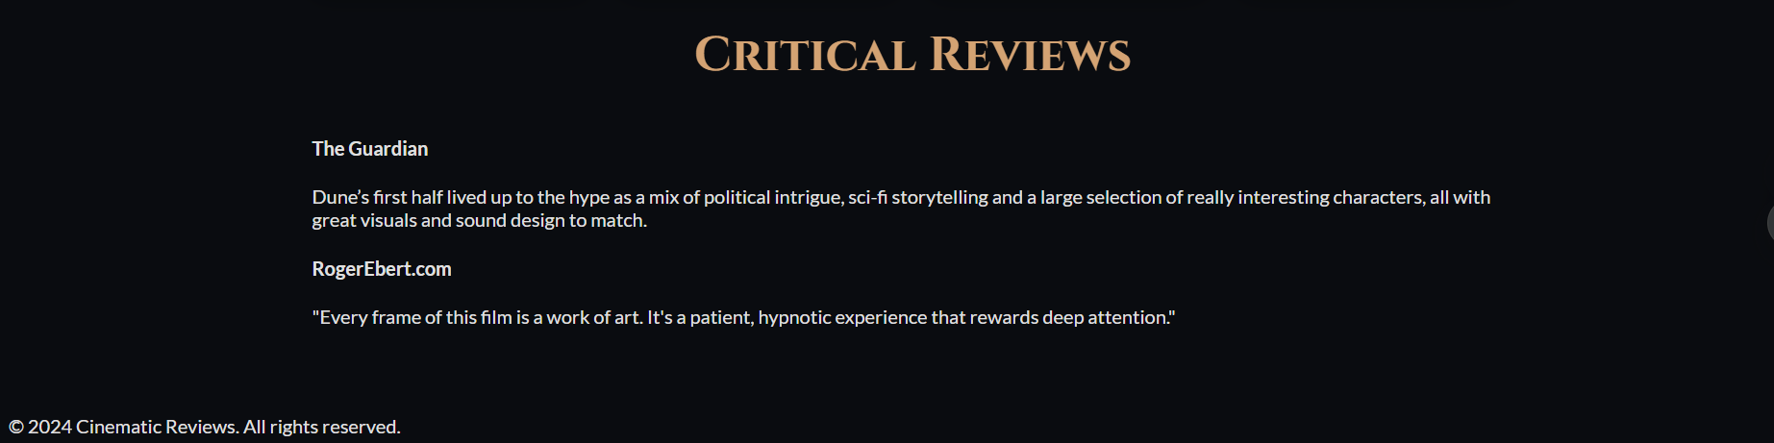

Caption: Blade Runner 2049

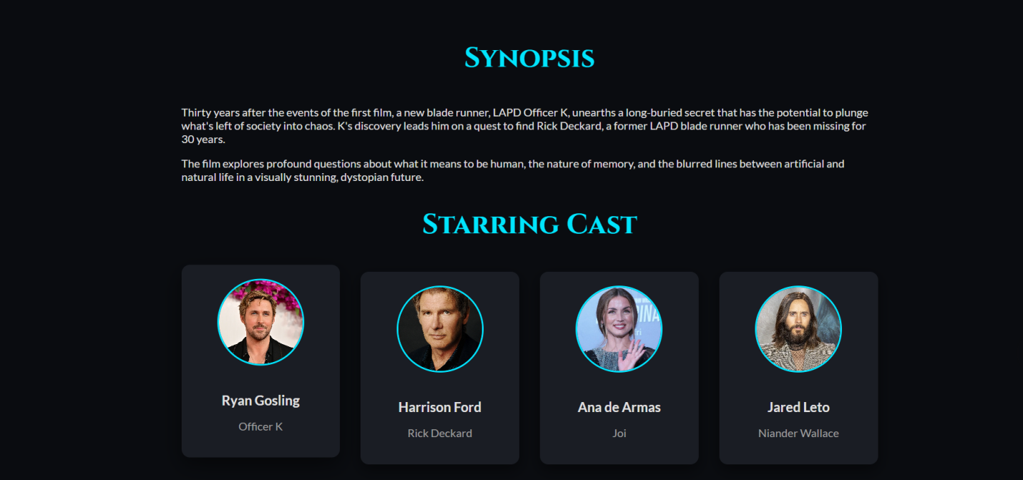

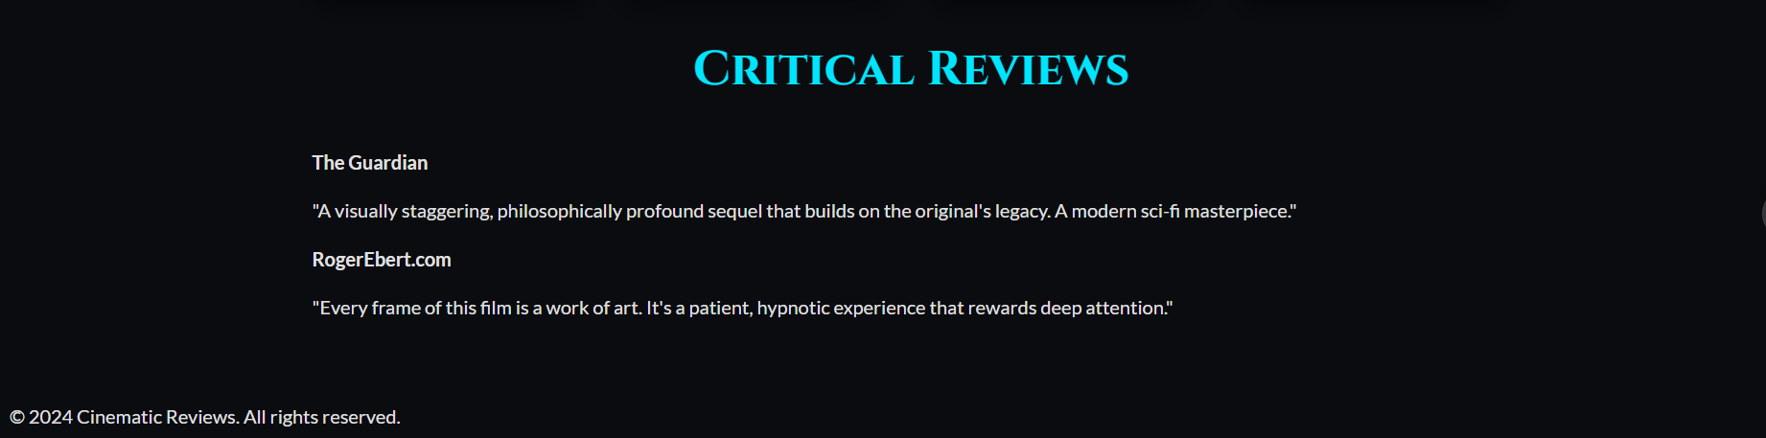

**14. Conclusion**

This project successfully demonstrates the creation of a multi-page, thematic website using only HTML and CSS. The site effectively showcases multiple movies in a visually appealing gallery and provides detailed information on dedicated pages, all while maintaining a consistent and responsive design. This project was instrumental in strengthening front-end development skills, particularly in the areas of advanced CSS layouts, responsive design principles, and thematic branding. The hands-on implementation provided deep insights into structuring a cohesive user experience across a multi-page website.

**15. References**

* **L&T EduTech LMS:** https://learn.lntedutech.com/Landing/MyCourse
* **MDN Web Docs:** For HTML & CSS reference.
* Google